Nuke Reference written by Ryan Wiley, 2018
Here is an example node tree for a shot with an environment, nine lights, three characters, particle effect, depth of field effect, motion blur effect, a pseudo 3d lighting effect, an animated ground displacement effect, and masks for almost every element in the shot. We used a left-right flow direction for our layout instead of the nuke standard top-down.
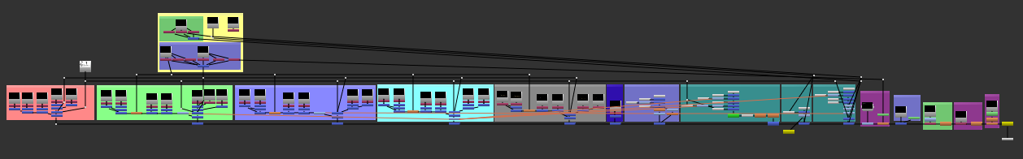
This document will attempt to cover each of these sections of compositing a Renderman scene captured from Maya.
We are going to assume a few things about this Renderman scene. Each light will be rendered separately and with a white color (except the ambient light) to allow us to more easily tone lights during compositing. Each character in the scene will be rendered separately using only the lights that affect that character. Instead of using a shadow pass, we will divide the direct occluded passes by the direct unoccluded passes to separate the shadows for modification. We will be multiplying the indirect unoccluded passes by the ambient occlusion pass and will not be using any indirect occluded to simulate an older style of render setup. The background matte paintings will use a pxrConstant material, and will show up in the emissive pass. We used individual images for each pass rather than a combined exr as we were having issues with the Maya batch renderer not liking that particular setup.

Environment
For this particular shot we used five lights that directly affected the environment; ambient (dome light without shadows, toned blue), moon (spotlight with barn doors), city (spotlight), lumin (sphere light from an animated character), and cane (sphere light from another animated character). For each set of lights we did not use groups, even though they could help with keeping the node layout a little cleaner (we used them later with the characters).

Ambient Light Group
The ambient light is a little different than the others as we did not want any shadows being cast (we wanted to use it as a way to tone the shadow color for the entire scene) so there are fewer layers for this set of passes.
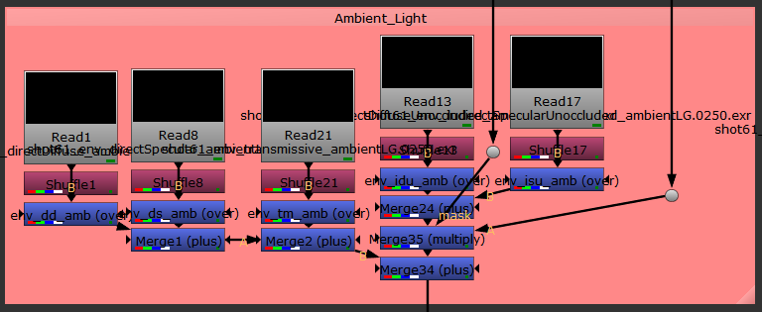
From left to right, the read nodes represent the directDiffuseUnoccluded (DDU), directSpecular (DS), transmissive (T), indirectDiffuseUnoccluded (IDU), and indirectSpecularUnoccluded (ISU) passes. For the purpose of short handing a few of these highly repeated terms, I will be using abbreviations after the first full use of the term. The reason we did not use a directSpecularUnoccluded (DSU) pass is that there was no discernible difference between DS and DSU.
During rendering we used multiple computers and also had to rerender multiple sets of frames, and during some of our re-render attempts we changed a setting in Renderman that made passes render to the RGBA channels rather than the appropriately named channels; meaning that the DDU read node would be outputting RGBA.r/g/b/a on some frames and directDiffuseUnoccluded.r/g/b/a on other frames, making it difficult to properly comp all the passes. Instead of rerendering all the frames or using nuke to write out all the frames with corrected channel names, we used a shuffle and merge-over; the merge node would basically mix in both channels at once, but one set of channels would always be black making a cohesive set of frames as the output of that merge node.
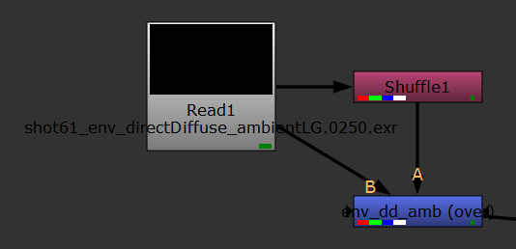
We used merge-plus, as Renderman passes are designed to be used in additive compositing (-re the second note on this page). Traditionally shadow passes are meant to be multiplied into a node tree unless otherwise stated (as the shadow_diff pass in Arnold is meant to use a merge-difference node), but you have to be carefull and respect the mathematical order of operations (higher level math will be calculated first, but respect parentheses/brackets). To make sure we did not mix in a merge-multiply node that would modify all upstream information, we made sure to section off portions that needed shadow information using a merge-plus node.
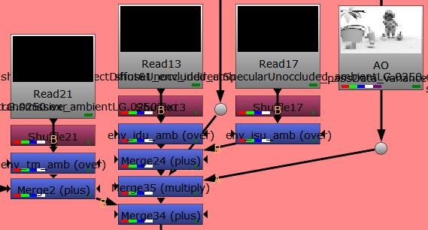
ISU
IDU
Transmissive
Upstream
Downstream
The IDU and ISU both need ambient occlusion (AO) multiplied onto them (we did this instead of using the standard indirect occluded passes for stylistic reasons). Instead of multiplying IDU and ISU by the AO individually, we merge-plused them first, then merge-multiplied the AO onto the output from the merge-plus node, saving a step. The output from the AO merge-multiply node is then merge-plused into the main node flow. The main main flow of pass data is not being multiplied and the AO will not affect the downstream data, only the IDU and ISU passes. Here is this node tree represented in mathematical notation to make it a little easier to understand:
DD + DS + T + [(IDU + ISU) * AO]
One thing you may have noticed is that there is a mask coming into the AO merge-multiply node. Since we only rendered out the AO once, including the environment and characters, we only want to merge in the environment portions of the AO at this point in the node layout. To isolate just the environment we need to either rotoscope out the characters across every frame (very tedious, even though this would be required if we were compositing a live action shot) or use masks. We generated animated masks using Renderman’s matteID passes.

Masks/MatteIDs
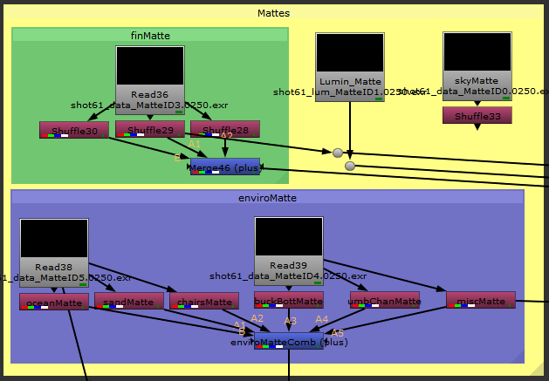
We used mattes for each our three characters, the environment, and the background sky. Elements of each were also separated into mattes, and to get the matte for a greater element we would combine lesser mattes. The environment used two mattes with three colors each, where each color had a few objects that did not visually overlap each other.
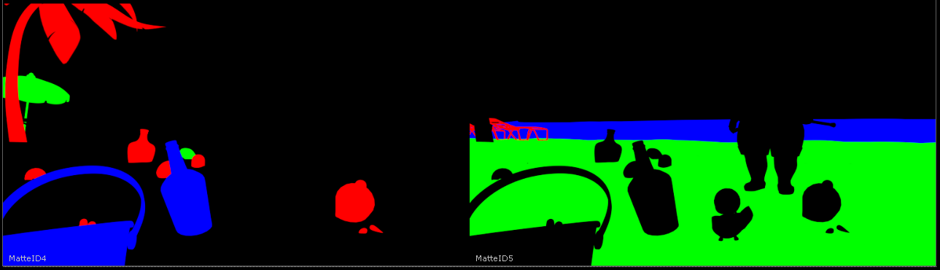
We also combined some objects in colors if they would not need to be modified separately during compositing (i.e. the two background beach chairs). To get a matte of just the environment, we needed to combine all the separate color channels using shuffle nodes and a merge-plus node. Each shuffle node would take one color from one pass and push it to each color (though we could just use one color) of the output of that shuffle node.
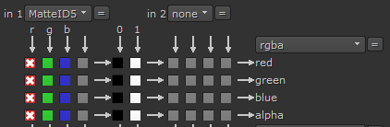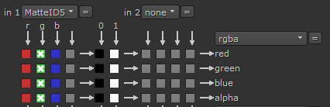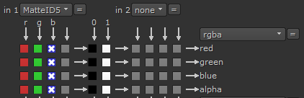
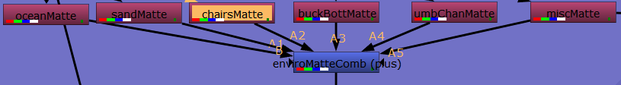
Since the merge node is using addition, it does not matter which order we plug in the shuffle nodes. The resultant output was now perfect to use as a mask for anything affecting the entire environment (i.e. the AO pass).
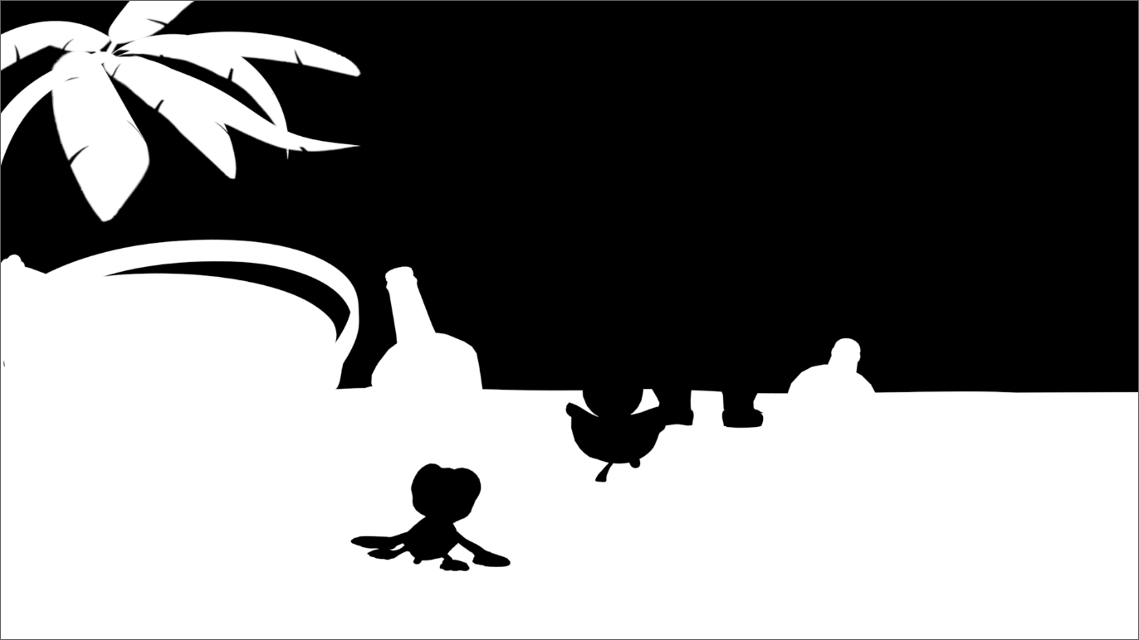
We will come back to masks, and problems we ran into, later (we forgot to generate masks for some things, i.e. half a character).
Here was what the Ambient Light Group for the environment looked like.
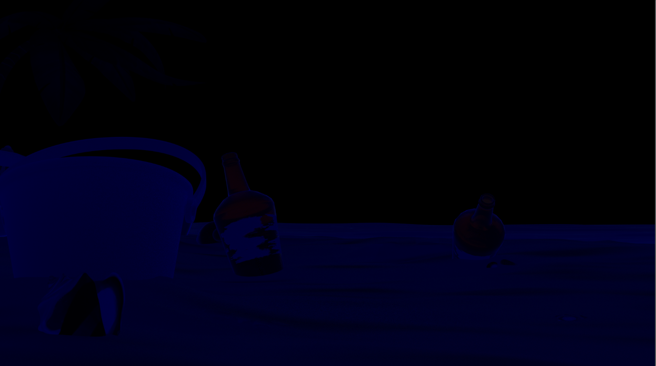
Very dark, but it was only meant to fill in the pure black shadows with a little bit of color.

Cane Light Group
The cane light passes are mixed more like the other light groups, in that they include directDiffuse (DD) and DS.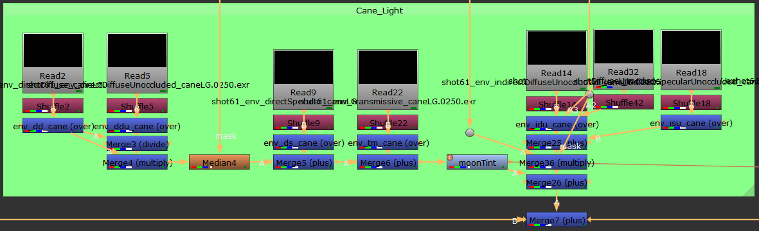
Upstream
Downstream
Sand Mask
Environment Mask
AO
Here is math for this light group:
DD / DDU * DD * Median Blur + DS + T * Color Grade + [AO * (IDU + ISU)]
The DD pass was a little noisy on the sand so we applied a median blur to it, making sure to use the mask we already had for the sand. We also had a color grade node (named moonTint) because we wanted to match the color from the moon light with this light. The moonTint node is a clone from the Moon Light Group and so they share settings (it is also cloned to the three characters).
Another problem we had to fix is that a single frame from the IDU pass for this light was corrupted, namely frame 367, and it would cause Nuke to fail rendering that frame at the end of the node layout. Instead of rendering the entire frame over again, we used a duplicate read node with a frame range of 100-366 and 368-430 to essentially skip that frame. If you have to butt two sets of frames up against each other in this way, you need to make sure a few settings are changed in the read nodes. Next to the frame ranges boxes, make sure they are set to “black” instead of the default “hold”, or else when you merge the read nodes, you will get ghosting from the last frame of the first node.
Here was the Cane Light Group mixed with the previous light:
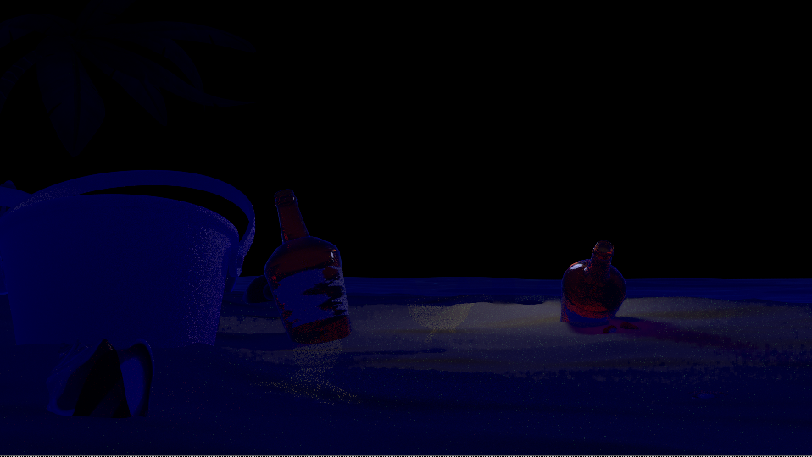

You can start to see where the environment mask and sand mask are preventing changes in the shot where the characters will eventually occlude the background.

City Light Group
The city light was composited much the same as the others, with a median blur to clear the noise on the sand. A color correct node was added to this light, as we wanted the light from the city to fluctuate in intensity and color over the course of the shot. When you have a particular type of pass and object in the scene that are noisy (i.e. our sand and the DD pass) and you want to use a median blur to try and correct that, you have to apply the median blur to every light group that has that pass and effects that object. For our sand, that was four different lights, hence four median blurs just for the sand.
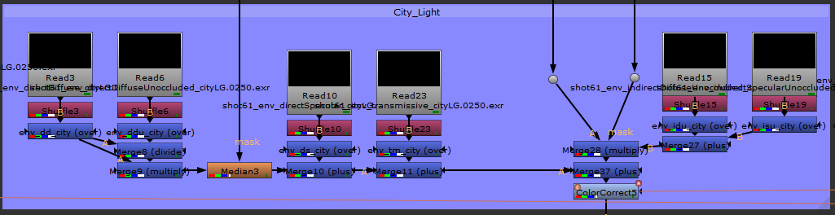
Upstream
Downstream
Sand Mask
Environment Mask
AO
Animated Flashing Light
DD / DDU * DD * Median Blur + DS + T + [AO * (IDU + ISU)] * Color Correction
Inside the master drop down of the color correct, we used the color wheel along with the curve editor to make this light group appear as if the city “behind” the camera was flashing brighter and brighter with different colors. This was initially done in Maya with Renderman but the intensity of the lights was not strong enough, so we took it further in Nuke.
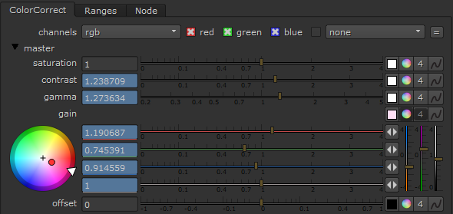
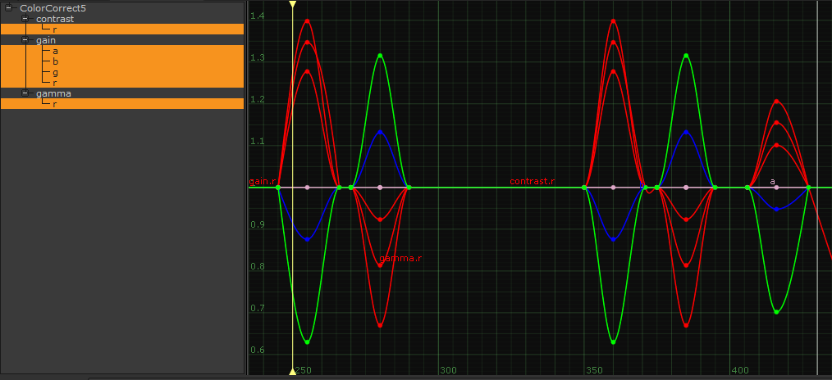
Here was the added city light group:
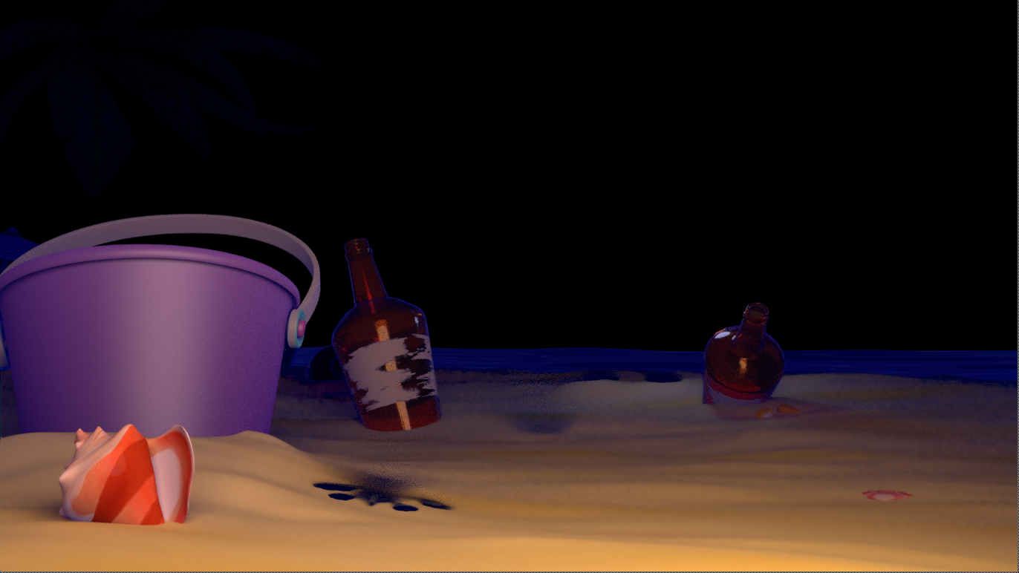
It was really easy to see shadows cast by the characters into the environment.

Moon Light Group
Again, more of the same. Here the moonTint color grade node makes an appearance because we wanted the moon to have a slight blue tint.
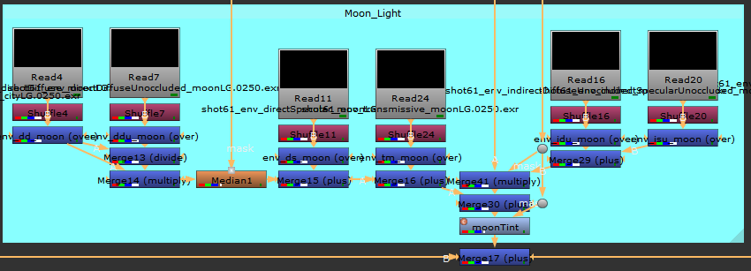
Upstream
Downstream
Sand Mask
Environment Mask
AO
Blue Tint for the Moon
DD / DDU * DD * Median Blur + DS + T + [AO * (IDU + ISU)] * Color Grade
The moonTint setup is pretty straightforward.
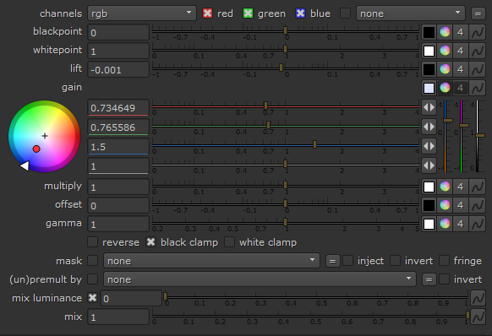
Here was the added moon light group:
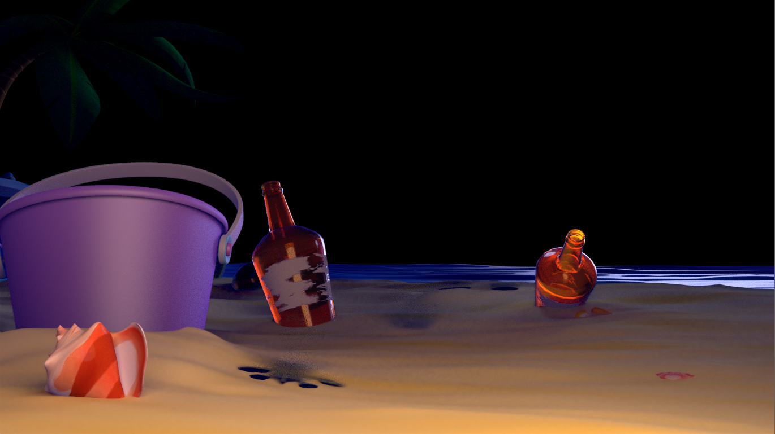
The ocean really started to pop and the palm tree slowly revealed itself.

Lumin Light Group
This light was named after one of our characters, since he himself is a light.
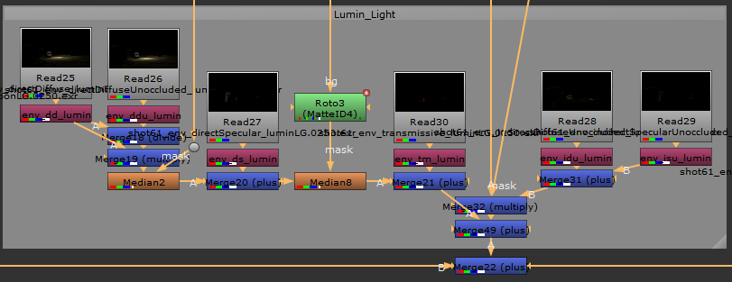
Upstream
Downstream
Sand Mask
Environment Mask
AO
Bucket & Bottle Mask
DD / DDU * DD * Median Blur + DS * Median Blur + T + [AO * (IDU + ISU)]
The second median blur here was to help with noise on the bucket in the DS pass. The only problem is that the bucket shares a mask with a bottle, but they do not overlap each other during the shot. We did a very simple rotoscope with only six key frames to follow the bottle and generate a new mask just for the bucket.
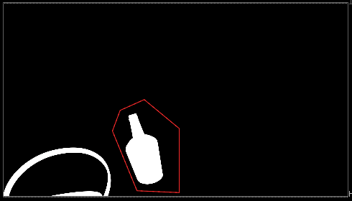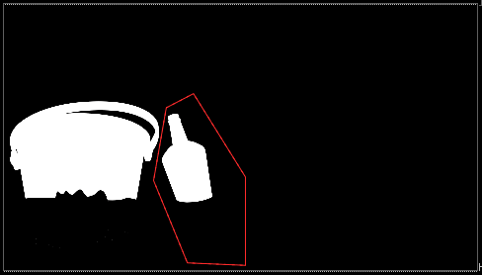
Here was the added lumin light group:
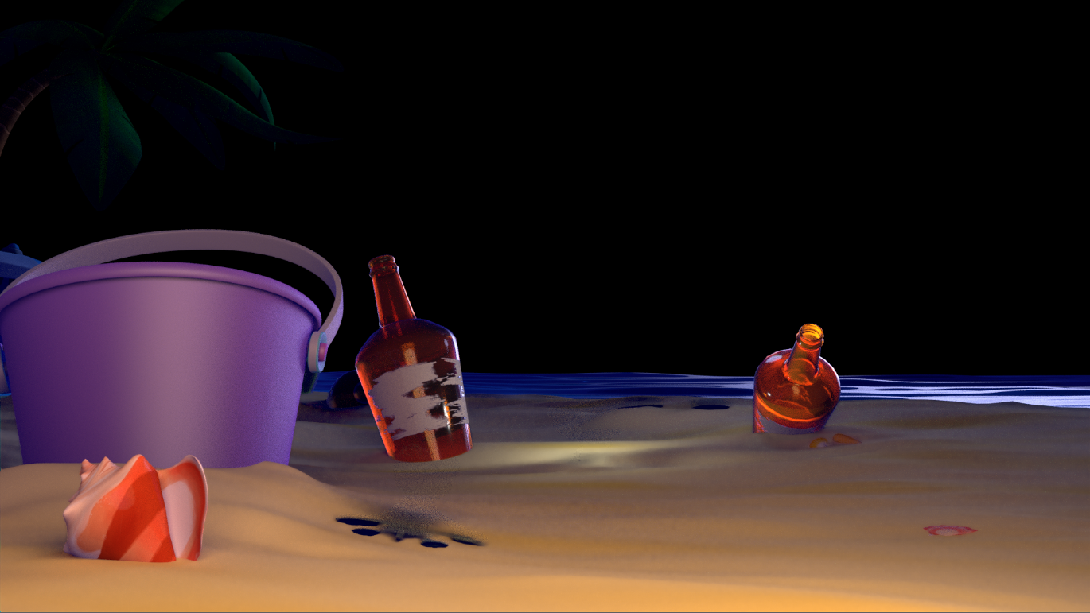

Sky Matte Painting
This was a really simple pass to composite in, as everywhere in the shot where the sky pass would be visible was black, and the sky pass was black everywhere the environment would otherwise overlap it.

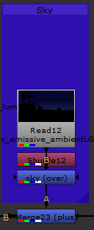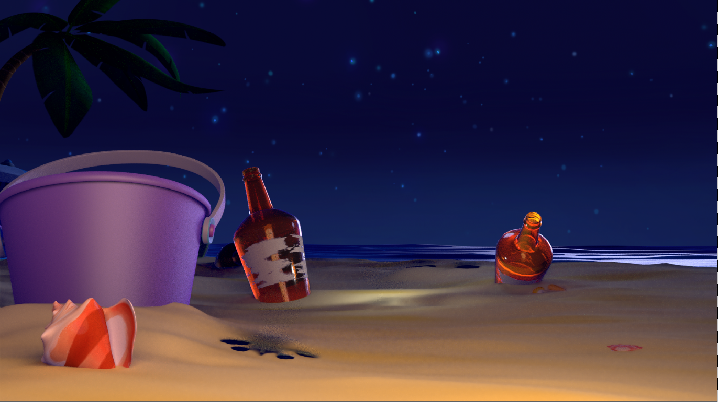

Ground Displacement
An effect we were using for our film was an animated ground displacement when the characters walked on the sand. For this shot we had to comp the displacement separately since the effect was not ready when we initially rendered the environment. We also failed to render with alpha or a mask for the piece of sand.
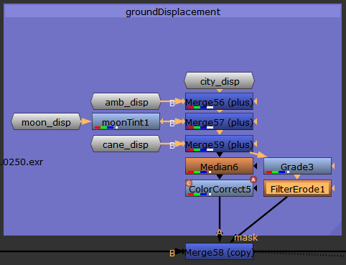
At this point in the node tree we decided to start using node-groups to simplify the layout. The groups you see are the same lights that affected the rest of the environment, except for the lumin light as he was physically far enough away in the scene that we did not need to render those passes. The moonTint node shows up again and the median blur was used to match the earlier use of it on the sand. The grade and erode nodes were used to create a non-perfect mask out of the RGB channels of the ground displacement itself.
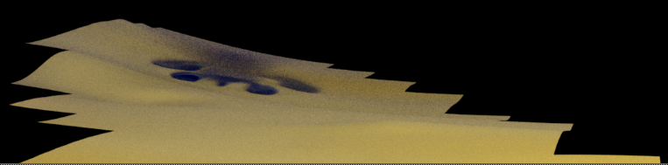
RGB
Grade
Erode
We then used a merge node and test numerous of the operation types until we found that the copy algorithm gave us the best results. Here it is in shot:
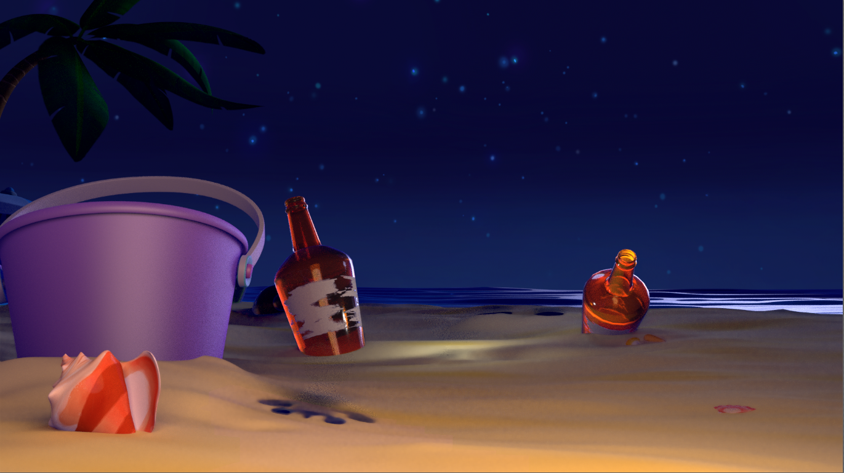
It blended in pretty well, and was hidden by a character as well as the depth of field effect that came later.

Characters
For this shot, we had all three of our characters visible; Mama Moon, Lumin, and Fin. Mama Moon and Fin had extra unique lights. Mama Moon and Lumin had animated lights that affected the environment. The characters were each rendered separately from each other and the environment and since two of them had unique lights, were more complex to composite than the environment; each character was organized using Nuke node groups to help keep the main node tree layout cleaner.

Mama Moon
Mama Moon had six light groups affecting her, making her the most complex node set. She was also missing a light and had missing masks. For our first runthrough of this shot, her missing light was not very noticeable and was thus left out until we would rerender and recomposited the whole shot with numerous other updates. An issue we had with all the characters was missing or misaligned masks. Mama Moon only had about half her geometry covered with masks.
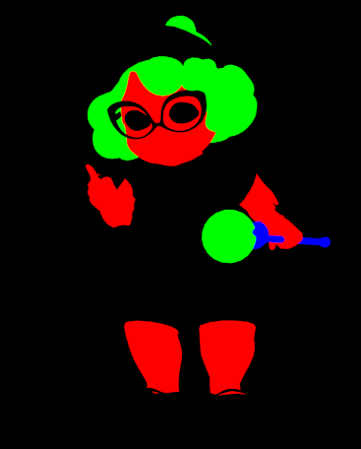
She was missing masks for all her clothing as well as her eyes. We first tried to reconstruct her masks taking the masks for element in the shot that was not her, then inverting it. The next problem we ran into was that the Lumin character occluded her a few times through the shot. This would not have been a problem, except that Lumin’s animation kept changing between renders, and the final animation for Lumin did not line up with the inverted mask for Mama Moon. We ended up using the same method we used to composite in the sand displacement and modified the RGBA channels from Mama Moon to generate her mask.
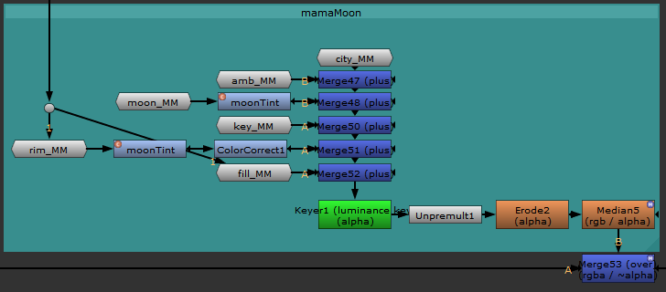
I am not going to show the full math for the rest of these since they included so many node groups. The moonTint node was repeated here since we wanted the tint applied to both the moon light and and her rim light.
If you highlight a group node and click ctrl+enter, the layout for that group opens in a new window. Here was Mama Moon’s city light node group:
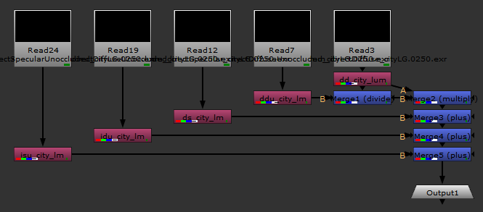
Since Mama Moon had no glass or visible lights, none of her node groups include the emissive or transmissive passes we used for the environment passes. You can add multiple output nodes and input nodes to allow connections outside the group node. If you select any number of nodes and click ctrl+g, you will create a group node which will ask you which connection to use as the default output.
This section of nodes created the missing mask we wanted for Mama Moon. The keyer created a new alpha channel based on the luminance of Mama Moon’s combined passes.
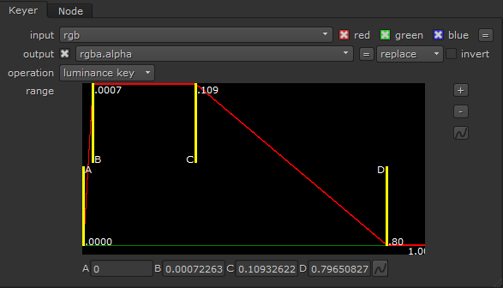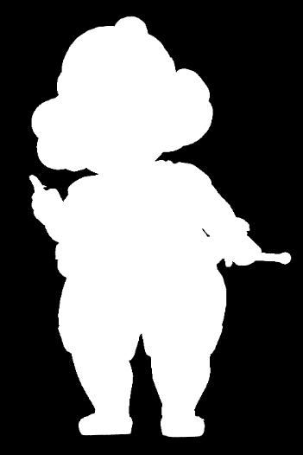
This worked only because she did not have any pure black in her passes except for the background. The new alpha extended a little to far past the actual edge of the passes so we used an erode node to pull it back in. Then we again added a median blur node to clean up noise. We used merge-over node with the previous composited passes, though using plus appeared to give the same result.
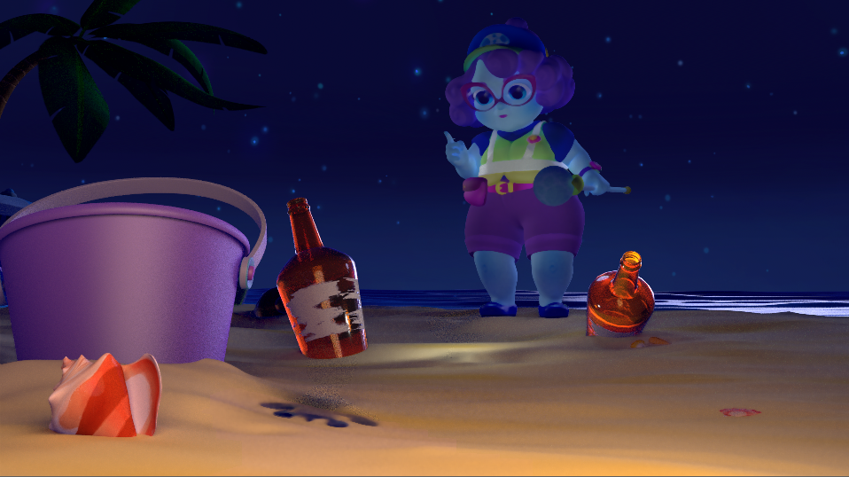

Lumin
Our Lumin character was somewhat easier to composite. He was an emissive character and so we decided to only use the ambient and his own light passes.
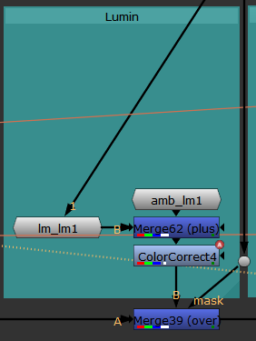
The color correct node was used to tone him down and draw attention away from him during this shot. We also used a few color correct nodes inside the groups to fluctuate Lumin in time with the city (this was for story purposes) as well as more median blur nodes.
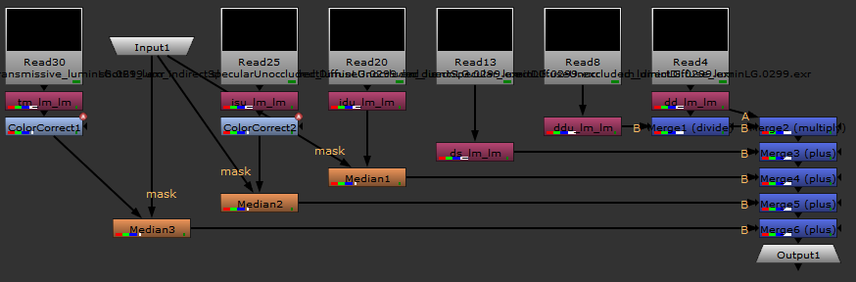
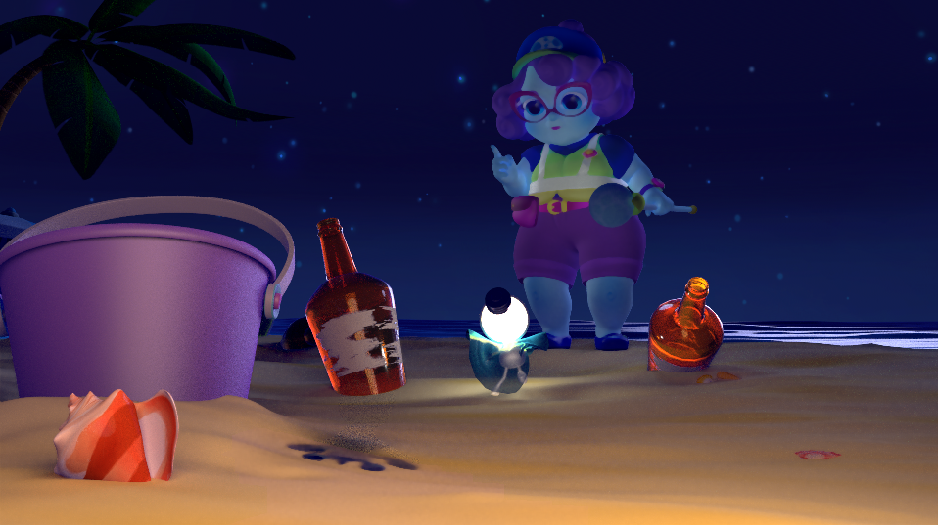

Fin
Our Fin character a little bit more work done on him.
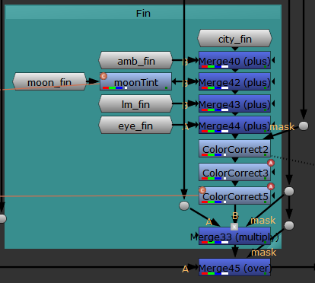
The first color correct was to make him more blue, as the yellow sand reflecting onto him made him too green. The second was to brighten him up as to draw focus. The third was a clone of the earlier node to mimic the city lights fluctuating.
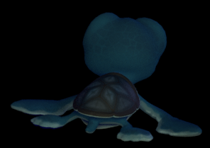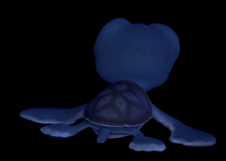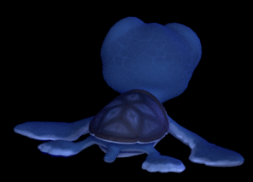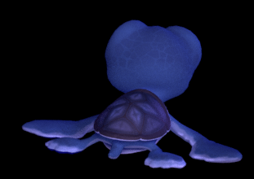
Original
1st
2nd
3rd
Fin also had a unique light (the eye_fin node group) that replaced the reflections in his eyes of the city light (they were originally too big).

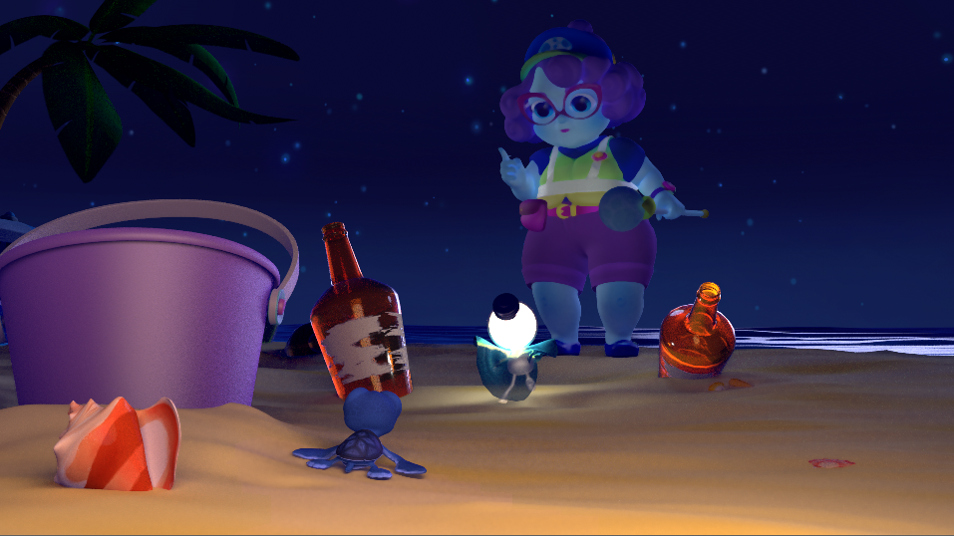

Effects

Palm Tree Light, ReLight
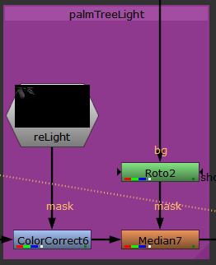
This was one of the more complex effects we used in this shot. When the lighting was originally designed for this shot, the palm tree had its own key light. During rendering setup, this light was missed and never had passes added for it and so, was not available for compositing. To test a new way to add lighting during compositing, we rendered two new passes called world position and world normal. We also saved out an .FBX file from Maya containing the animated camera from the shot. Using these passes and an .FBX file, we used a node called ReLlight, as well as a few other supporting nodes, to create pseudo 3D lighting in Nuke to replace missing lighting from the original shot. Once it had the extra lighting on it, the tree looked noisey and so, was given a median blur. The roto node was used to isolate the tree mask for the median blur. Inside the reLight group node was the entire setup for relighting the scene.
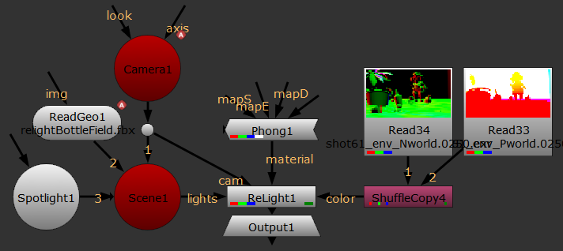
First, we added the relight node, then a shufflecopy node. Relight needed direct access to the two passes and we did not have them in a layered .EXR file, so we had to combine the channels.
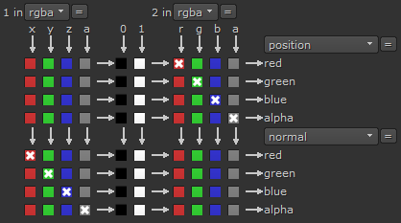
Next, in the relight node we selected the newly accessible channels. Those channels contained the world position and world normal at every pixel in the shot. Relight was able to use that to create the pseudo 3D surface information for the scene.
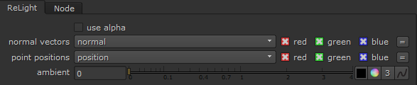
Next, we added a phong material and connected it to the relight node. The material told the relight node how the light interact with the surfaces of the scene (much the materials in full rendering engine). We turned down both diffuse and specular influence as it seemed too bright once a light was added.
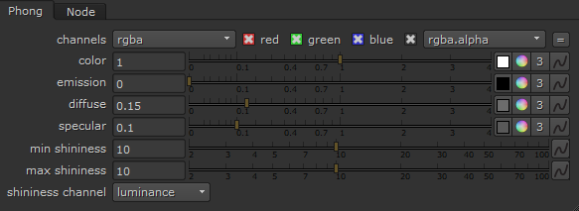
Next, we added a camera node and connected it to the relight node. This was the only node that specifically required an .FBX file, namely the animated camera from Maya. In Maya, we selected the camera, clicked the menu; File > Export Selection… We chose FBX as the file type. Under the options we made sure to select Animation, Bake Animation with every frame we needed, Use scene name, and Cameras.
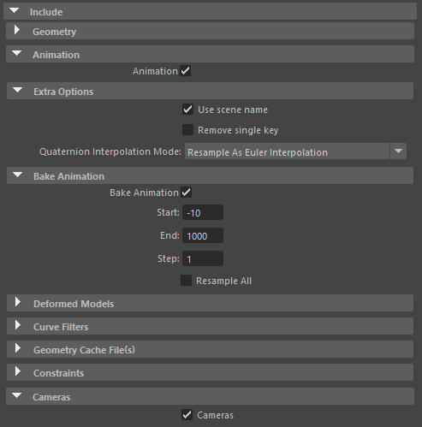
Then we made sure to choose FBX 2006 under the Version drop down, and then saved it in our compositing folder. Other versions may have worked, but when we tried 2016/2017, it did not seem to work inside nuke.
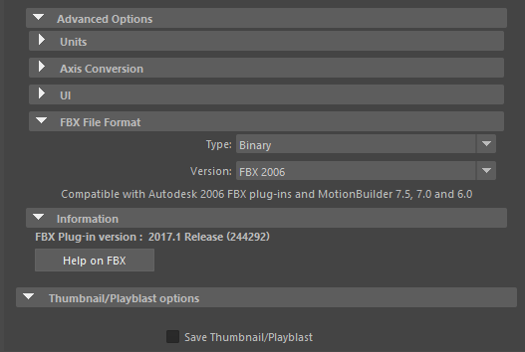
Back in Nuke, we loaded the camera .FBX from the file tab in the camera node, selected the proper names from animation stack and node drop downs, and made sure the frame rate was set to 24 (the rate our film was being animated at).
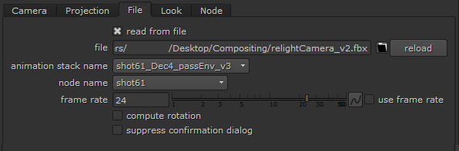
Next, we added a scene node and connected its output to the lights input of the relight node, and an input from the camera node. The scene node was not explicitly required for relight to work, but we wanted to have a navigable and viewable 3D scene to correctly place the light. None of the settings inside the scene node was changed.
Next, we added a readgeo node and connected it to the scene node. This node contained the geometry we needed for 3d reference. In maya we selected the ground plain and export selection like the camera, but his time exported just geometry and no animation, as the it was not animated during the shot. We also made sure to select the correct node name.
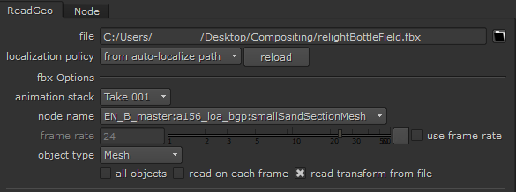
We finally added a spotlight node and connected it to the scene node. Once it was added the light, we could manipulate it in the 3D view. We clicked tab in the viewer to switch between the 2D and 3D mode.
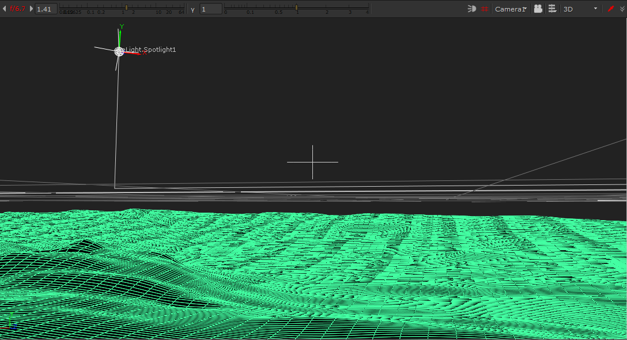
Switching between the view modes, we refined where we wanted the spotlight to go. We could hold ctrl in the viewer use the rotate handles vs the normally accessible translate handles. We also changed some settings in that node.
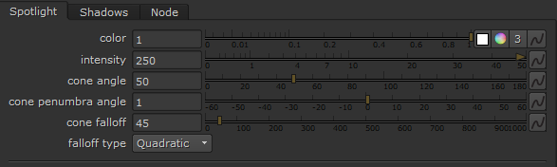

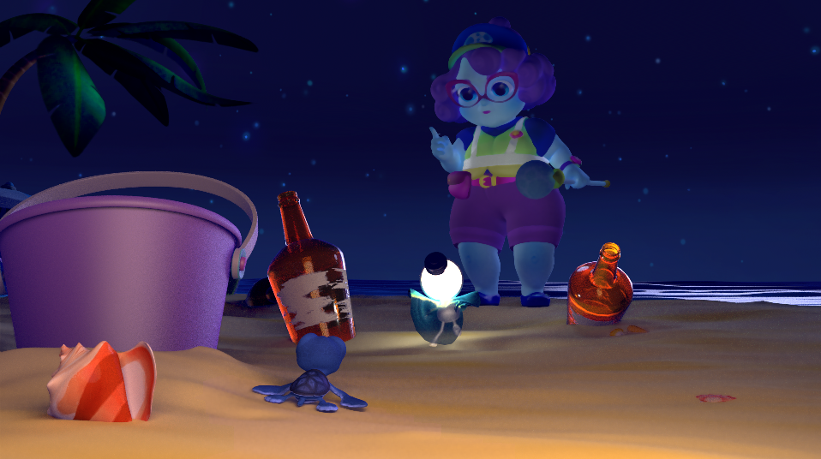

Cane Particle
The cane had a particle effect rendered from the Maya viewport and was simply merge-plused into the stream.
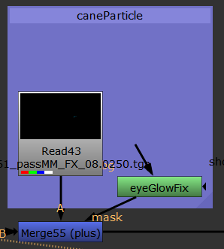
Downstream
The eyeGlowFix node is a rotoscope. For whatever reason there were some reflections in Mama Moon’s eyes showing up in that pass and the roto hid them.
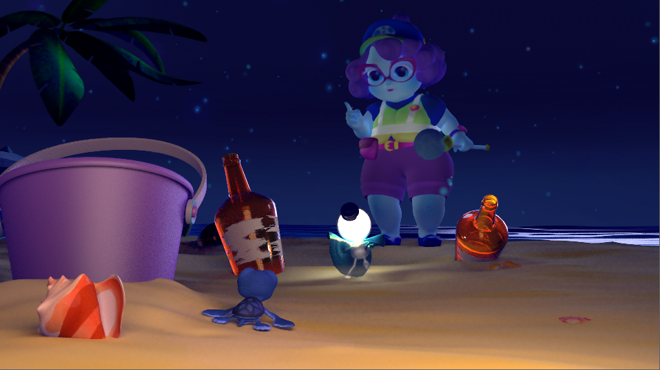

Depth of Focus
Our film’s scale was similar to that of the Toy Story films, in that two of our characters were only a few inches tall/wide and the largest was only about two feet tall. To emphasize this distinction in world scale, we used the size of the environment as a visual cue with normal objects being large in relation to the characters. We also used a strong depth of focus to help show this. We also used depth of focus to direct the viewer’s eye to certain elements in shot. The beginning of this particular shot starts with the focus on the two background characters arguing, it then shifts to Fin in the foreground and follows him as moves towards the camera.
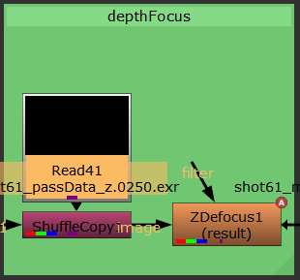
Downstream
Upstream

The shufflecopy node brought in the newly graded depth channel and mixed back into the main stream as the ZDefocus nodes does not allow you to map in the depth channel separately.
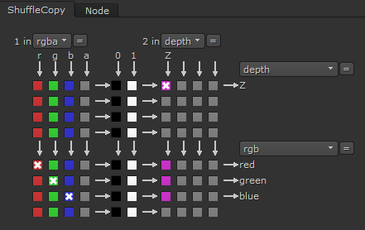
The ZDefocus nodes was then set to use the depth.Z channel as the depth channel. To animate the focus moving towards the camera during the shot, we had to key the focus plane (which was called “center” in the curve editor). We also animated the range of blur by keying the size and max size settings. As the focus moved closer to the Fin, the focus would also narrow down, so a wider blur.
To help us key the focus plane, we used the focal point guide inside the viewer. At the first frame, we dragged the focal point where we wanted focus, then right-clicked the focus plane setting and clicked Set Key. We then went through the timeline at the frames we wanted to change the focus and then drag-n-dropped the focal point. The node would then autokey the changes. We then manually keyed the size as needed with a larger size resulting in a stronger blur outside the focus plane. We turned off automatic layer spacing, as it seemed to add distortion to really deep portions on some frames. Most other settings we left at default.
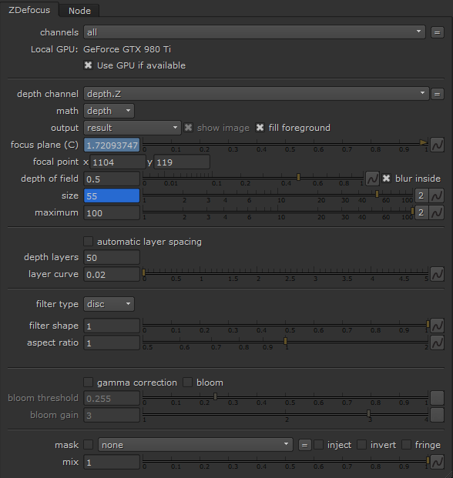
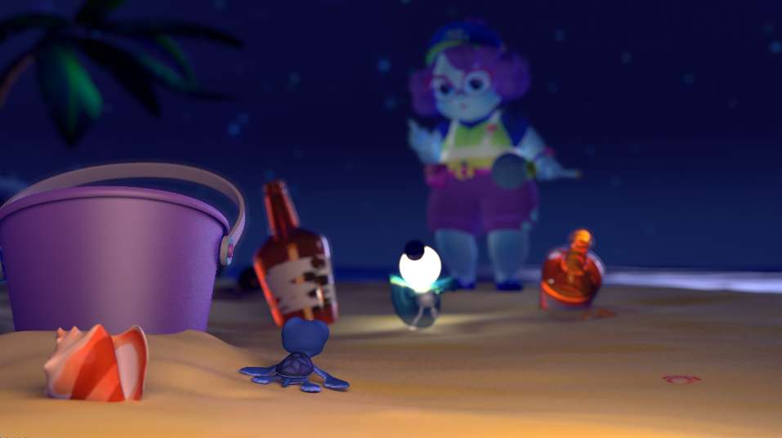

Motion Blur
The motion blur required the same type of shufflecopy setup as the Depth of Field and for the same reason.
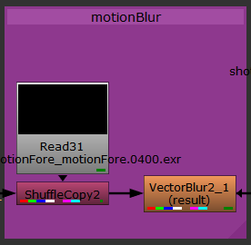
Downstream
Upstream
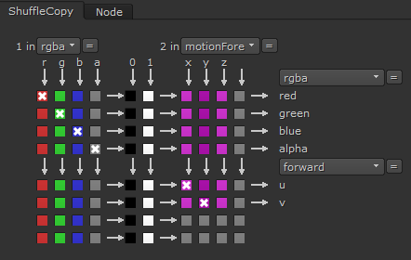
For our production we used the VectorBlur2 type motion blur as it was simple and worked directly with the motionFore pass from Renderman. We set the uv channels to our custom channel called forward, set the mv preset to PRMan, uv offset to -0.5 (recommend for motion from a file), and the motion amount to 0.5.
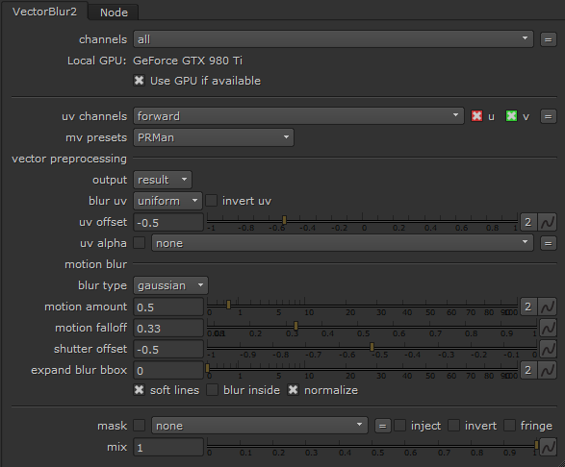
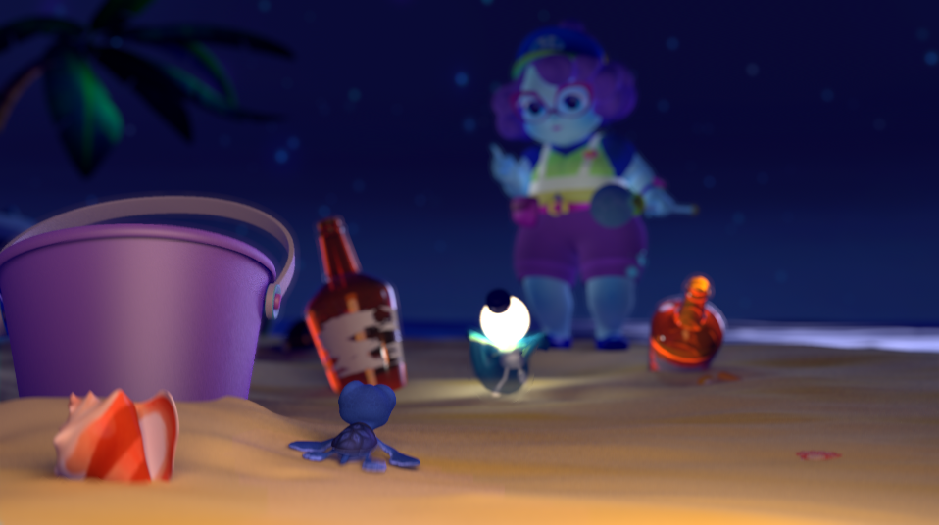

Cane Glow
We wanted Mama Moon’s cane top to have a soft glow to it, and it ended up being the last alteration to this particular shot.
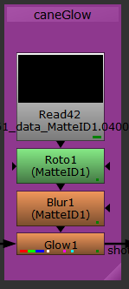
Downstream
Upstream
As we showed earlier we did not have a full set of masks for Mama Moon, but we did have one for her cane. The cane top mask and hair mask shared the green color and required a roto to hide the hair. Then the mask was blurred so the effect would extend past the visual bounds of the ball, and then a glow was applied.
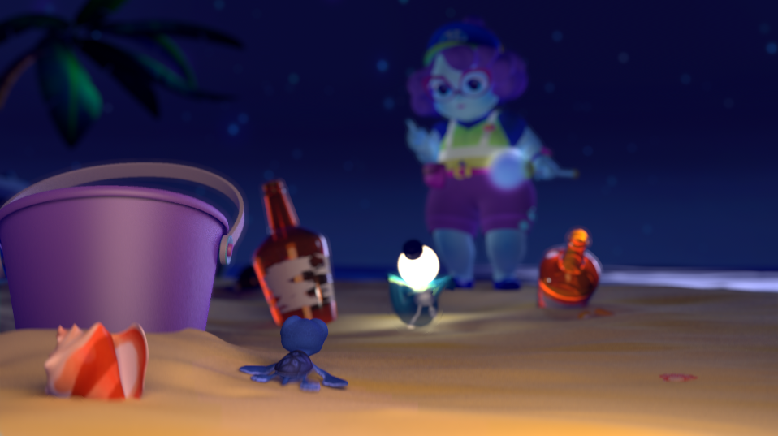

Final Render
The final render/write node was setup using targas as the file type. We wanted to be able to recover from a fatal error and if we tried to write directly to a video we could lose all progress if there was a problem. We used targa as the would still be have fairly deep color bit depth if any color correction needed to be done in Premiere.
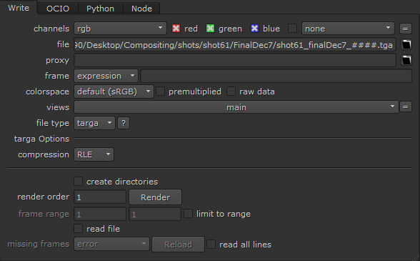

Concepts
Through the course of compositing this shot we used processes that may need more in depth explanation to understand, especially to be able to employ them in varying processes. I will try to cover some of these processes in this section.

Denoising
When we rendered and composited this scene we noticed an appreciable amount of noise showing in the passes rendered by Renderman. There a few ways to reduce noise using settings in Renderman alone; rendering at a higher sampling rate, using the inbuilt denoising tool, controlling more specific settings. This page has a lot of information for optimizing a Renderman scene. But if render times are still an issue while trying to reduce noise, then there are methods inside Nuke to help reduce noise.
The first thing you want to do if you see noise in your final output on a composited shot, is to browse through and view every individual pass used in that shot. Identify where the most noise seems to exist. If it is concentrated in the DD, you may have to repeat this process across every instance of DD used in your shot. If the noise seems to be on a particular object in the scene, it may be best to denoise on all the passes associated with that object simultaneously. Denoising across multiple objects may benefit from denoise each object separately, as the denoising process can blur the edges of details, and masking the operations from each other may help preserve those details.
For an object that does not have a lot of texture detail, than a simple masked median blur node may suffice to reduce noise.
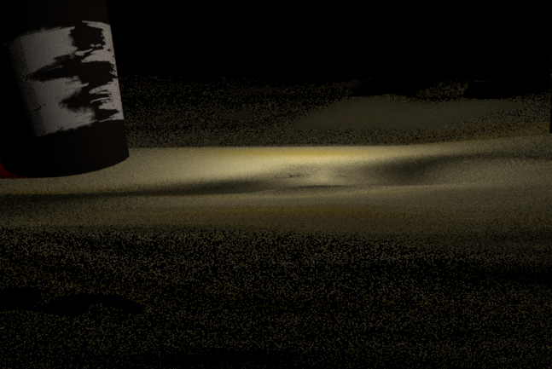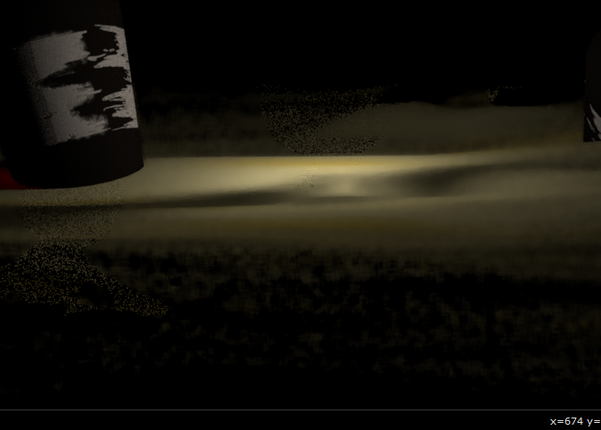
Median blur is not the cleanest method to reduce noise. Median does a pretty good job of attempting to preserve details while still blurring minute fluctuations. It will probably be better to apply it while masking out objects that are not as noisy, or doing multiple medians each with a mask for the object you want to denoise.
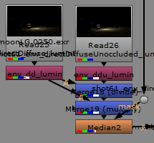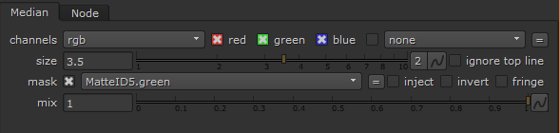
A problem occurs when you use a median blur on a pass/object with any real amount of texture detail. The texture will become blurred along with the rest of the surface you are trying to denoise. To get around this, you can isolate your median blur to only the lighting information and leave the “Albedo” (the albedo is a texture pass without lighting interacting with it) information alone. Renderman does not have a “Lighting Only” pass, but you can still simulate one. If you take a Diffuse pass and divide by the Albedo pass will give you the equivalent of a Light Pass.

